다양한 테이블 연습

**markup**

|  |
| --- |
| <!DOCTYPE html PUBLIC "-//W3C//DTD XHTML 1.0 Transitional//EN" "http://www.w3.org/TR/xhtml1/DTD/xhtml1-transitional.dtd">  <html xmlns="http://www.w3.org/1999/xhtml" xml:lang="en" lang="en" dir="ltr">  <head>  <meta http-equiv="Content-Type" content="text/html; charset=utf-8" />  <title>test</title>  <link rel="stylesheet" type="text/css" href="css/002.css" />  </head>  <body>  <table summary="This table lists all the flights by XYZ Air leaving London today.">  <caption>Flight Schedule</caption>  <thead>  <tr>  <th id="fn" scope="col">Techbug:</th>  <th id="fr" scope="col">User ID:</th>  <th id="to" scope="col">Companay:</th>  <th id="dp" scope="col">Departure:</th>  <th id="ar" scope="col">Arrival:</th>  </tr>  </thead>  <tfoot>  <tr>  <td colspan="5">Total: 3 flights</td>  </tr>  </tfoot>  <tbody>  <tr>  <th scope="row">BA 3451</th>  <td>Techbug</td>  <td>Nextree</td>  <td>19:20</td>  <td>19:50</td>  </tr>  <tr class="odd">  <th scope="row">BA 1254</th>  <td>Techbug</td>  <td>Nextree</td>  <td>19:40</td>  <td>20:50</td>  </tr>  <tr>  <th scope="row">LH 331</th>  <td>Heathrow</td>  <td>Hamburg</td>  <td>20:00</td>  <td>20:20</td>  </tr>  </tbody>  </table>  </body>  </html> |

**결과**

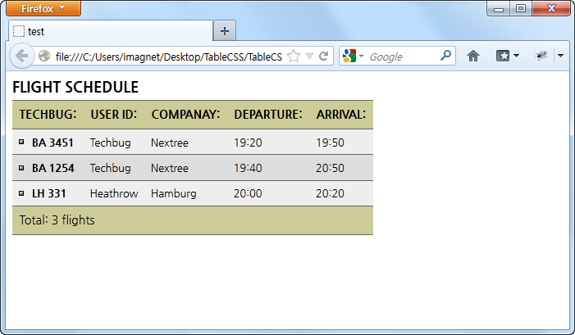

**css1**

|  |
| --- |
| @charset "utf-8";  table {  border-collapse: collapse;  font-family: "나눔고딕";  font-size: 0.8em;  margin: 0;  padding: 0;  }  caption {  font-size: 1.4em;  font-stretch: condensed;  font-weight: bold;  padding-bottom: 5px;  text-align: left;  text-transform: uppercase;  }  th, td {  border-bottom: 1px solid #666;  border-top: 1px solid #666;  padding: 0.6em;  vertical-align: 4px;  }  th {  text-align: left;  text-transform: uppercase;  }  thead th, tfoot th, tfoot td {  background-color: #cc9;  font-size: 1.1em;  }  tbody th {  background: url(http://www.clacksweb.org.uk/images/bullet_vacancy.gif) no-repeat 6px 0.8em;  padding-left: 24px;  }  tbody th, td {  background-color:#eee;  }  tbody tr:hover td, tbody tr:hover th {  background-color: #E5E5CB;  }  tr.odd td, tr.odd th {  background-color: #ddd;  }  tbody a {  color: #333;  }  tbody a:visited {  color: #999999;  }  tbody a:hover {  color: #33c;  }  tbody a:active {  color: #33c;  }  tbody td+td+td+td a {  background: url(http://www.clacksweb.org.uk/images/external.gif) no-repeat right 0.4em;  padding-right: 12px;  }  tfoot th {  text-align: right;  } |

**결과**

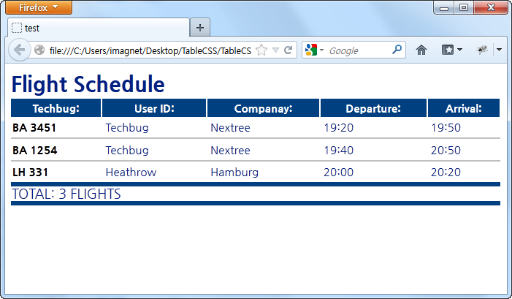

**css2**

|  |
| --- |
| @charset "utf-8";  table {  font-size: 95%;  font-family: "나눔고딕";  background-color:#fff;  border-collapse: collapse;  width: 100%;  line-height: 1.2em;  }  caption {  font-size: 30px;  font-weight: bold;  color: #002084;  text-align: left;  padding: 10px 0px;  margin-bottom: 2px;  text-transform: capitalize;  }  thead th {  border-right: 2px solid #fff;  color:#fff;  text-align:center;  padding:2px;  height:25px;  background-color: #004080;  }  tfoot {  color:#002084;  padding:2px;  text-transform:uppercase;  font-size:1.2em;  font-weigth: bold;  margin-top:6px;  border-top: 6px solid #004080;  border-bottom: 6px solid #004080;  }  tbody tr {  background-color:#fff;  border-bottom: 2px solid #c0c0c0;  }  tbody td {  color:#002084;  padding:5px;  text-align:left;  }  tbody th {  text-align:left;  padding: 2px;  } |

**결과**

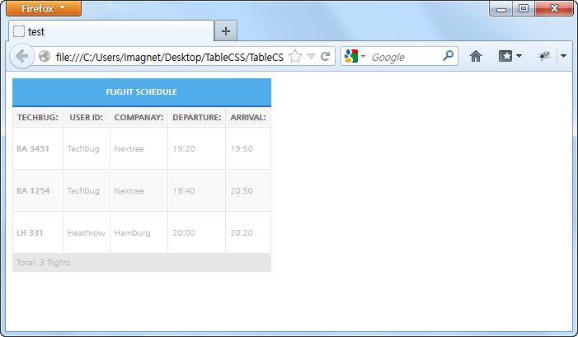

**css3**

|  |
| --- |
| @charset "utf-8";  table {  border-spacing:1px;  font-family: "나눔고딕";  font-size:10px;  background-color:#E7E7E7;  color: #b7b7b7;  }  caption {  font-weight: bold;  background: #50ADEA url(http://infectedfx.net/css/tables/corner.gif) no-repeat right top;  border-bottom:2px solid #1975d7;  color: #FFF;  text-transform:uppercase;  padding:10px;  }  td, th {  padding: 4px;  }  thead th {  text-align: center;  background: #F5F5F5;  color: #666;  border: 1px solid #FFF;  text-transform:uppercase;  }  tbody th {  font-weight: bold;  }  tbody tr {  background-color:#FFF;  text-align:left;  }  tbody tr.odd {  background: #f9f9f9;  border-top:1px solid #FFF;  }  tbody tr td {  height:50px;  background: #FFF;  border: 1px solid #FFF;  }  tbody tr.odd td{  background: #f9f9f9;  border-top:1px solid #FFF;  } |

**결과**

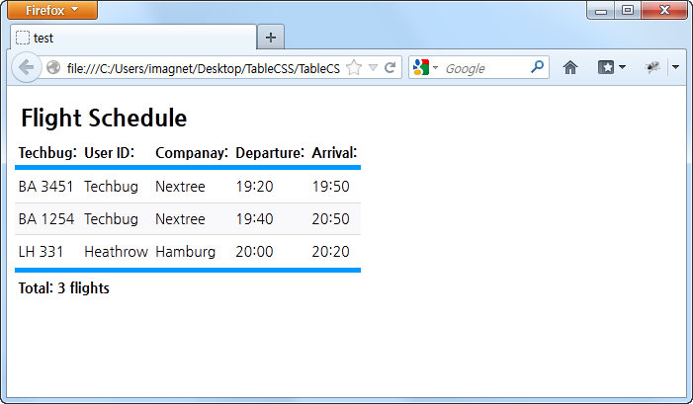

**css4**

|  |
| --- |
| @charset "utf-8";  table {  font: 88%/1.7em "나눔고딕";  border-collapse: separate;  border-spacing: 0;  margin: 0 0 1em 0;  color: #000;  }  thead th, thead td {  font-weight: bold;  line-height: normal;  text-align: left;  border-bottom: 0.4em solid #09f;  }  tfoot th, tfoot td {  text-align: left;  border-top: 0.4em solid #09f;  font-weight: bold  }  th, td {  padding: 0.25em;  }  tbody th, td {  text-align: left;  vertical-align: top;  }  tbody th {  font-weight: normal;  white-space: nowrap;  }  tbody th + td {  white-space: nowrap;  }  tbody td, tbody th {  border: 1px solid #fff;  border-width: 1px 0;  }  tbody tr.odd th, tbody tr.odd td {  border-color: #deded8;  background: #f9f9fb;  }  tbody tr:hover td, tbody tr:hover th {  background: #fbfbf8;  }  caption {  font-weight: bold;  font-size: 1.7em;  text-align: left;  margin: 0;  padding: 0.5em 0.25em;  } |